**District Photo Online Learning Standard:**

**In preparation for college and career experiences we use instructional online sites. Sites like Edmodo, and Moodle permit us to become familiar with using profile images that have an academic and/or a professional tone.**

**Useful is a photo that:**

* Show only you, fully facing the camera — there cannot be any other people in the image
* Shows your head and shoulders only, fully facing the camera
* Does not have anything obscuring your face, such as hair, hands, shadows or glare
* Does not show you with a covered head unless for religious purposes (see below)
* Is easily recognizable as you
* Is properly focused and does not appear fuzzy, grainy or have visible pixels
* Is properly exposed to eliminate shadows and flash reflections
* May be used with our career and college partners

**Head coverings, prescription glasses or other articles:**

* If you wear a hat or head covering for religious purposes, it may be worn for your photo. Make sure your full face is visible, and that the hat or covering does not cast any shadows on your face
* If you wear prescription glasses, a hearing device or similar articles, they may be worn for your photo. Avoid glare from eyeglasses by tilting them slightly downward, by removing the glasses or by turning off the camera flash.

Not to be used: copyrighted pictures or illustrations, advertisements or logos. Examples below:

|  |  |
| --- | --- |
| cceptable photos | **Examples of acceptable photos** |

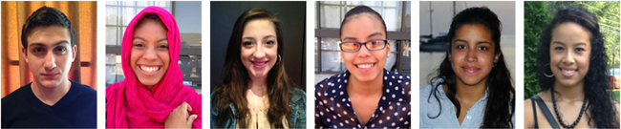________________

|  |  |
| --- | --- |
| on-acceptable photos | **Examples of non-acceptable photos** |

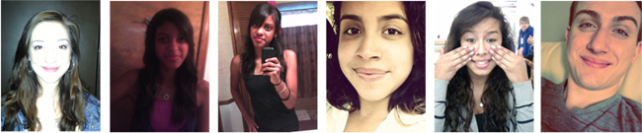 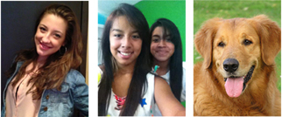

Too Light Too dark Too far Too Close Face cover Head cut ¾ shot To be alone Must be human

Content source: <http://sat.collegeboard.org/register/photo-requirements> Revised 1/8/14---M. Holloway