Installing eQUEST

You will need a computer running windows. If you don’t have access to a windows laptop, please let me know. I am working on possible work around options for running on Mac or potentially other solutions.

Go to:
https://doe2.com/equest/
Download eQUEST Version 3.65 by clicking the link
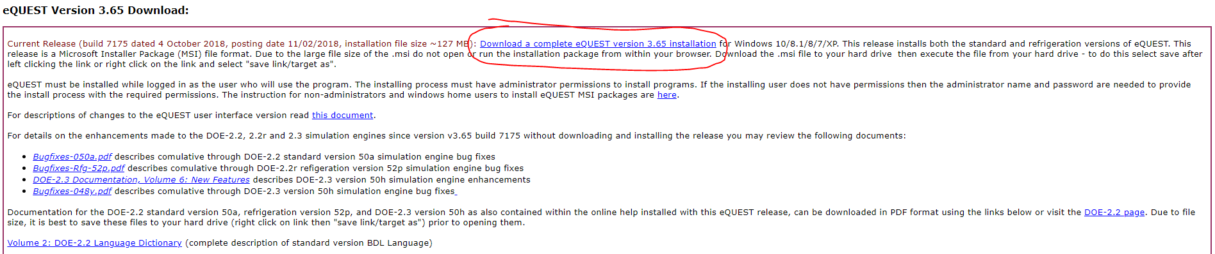

Follow the install instructions. Open eQUEST to confirm it is running.

Once you have loaded eQUEST you will need to load the weather files to be able to run it.
Go to Moodle/Canvas and download the TMY3 Zip file.
Extract the files into the eQUEST 3-65 Data > Weather Folder
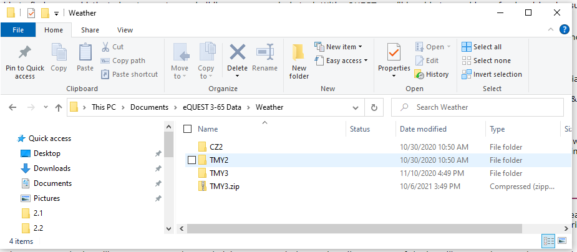
Note you will likely not have TMY2 or CZ2 data in the Weather folder

